

Artificial Intelligence Lab 08 Tasks

**Name:** Alishba Waqar

**Sap ID: 46997**

**Batch:** BSCS-6th semester **Lab Instructor:** Ayesha Akram

**Task1. Solution:**

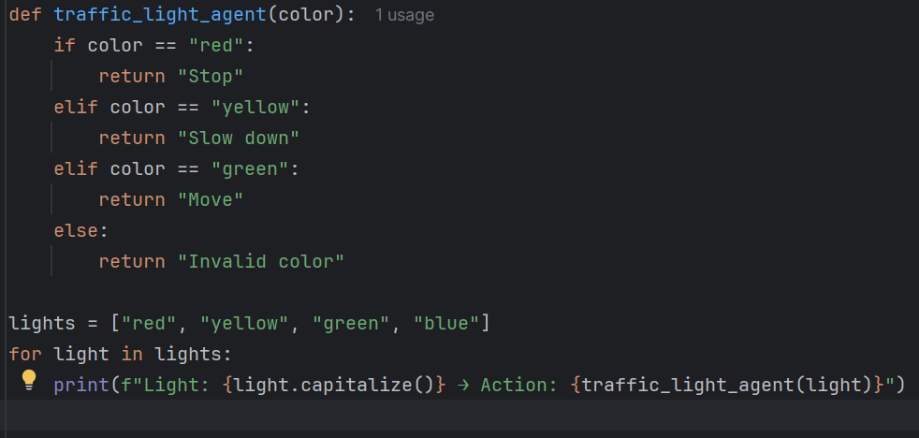

**Task2. Solution:**

**Task3. Solution:**



